Changes made to H_tv which is the higher order filter matrix associated for higher order translational modes.

On p9 of the Haugen formulation:

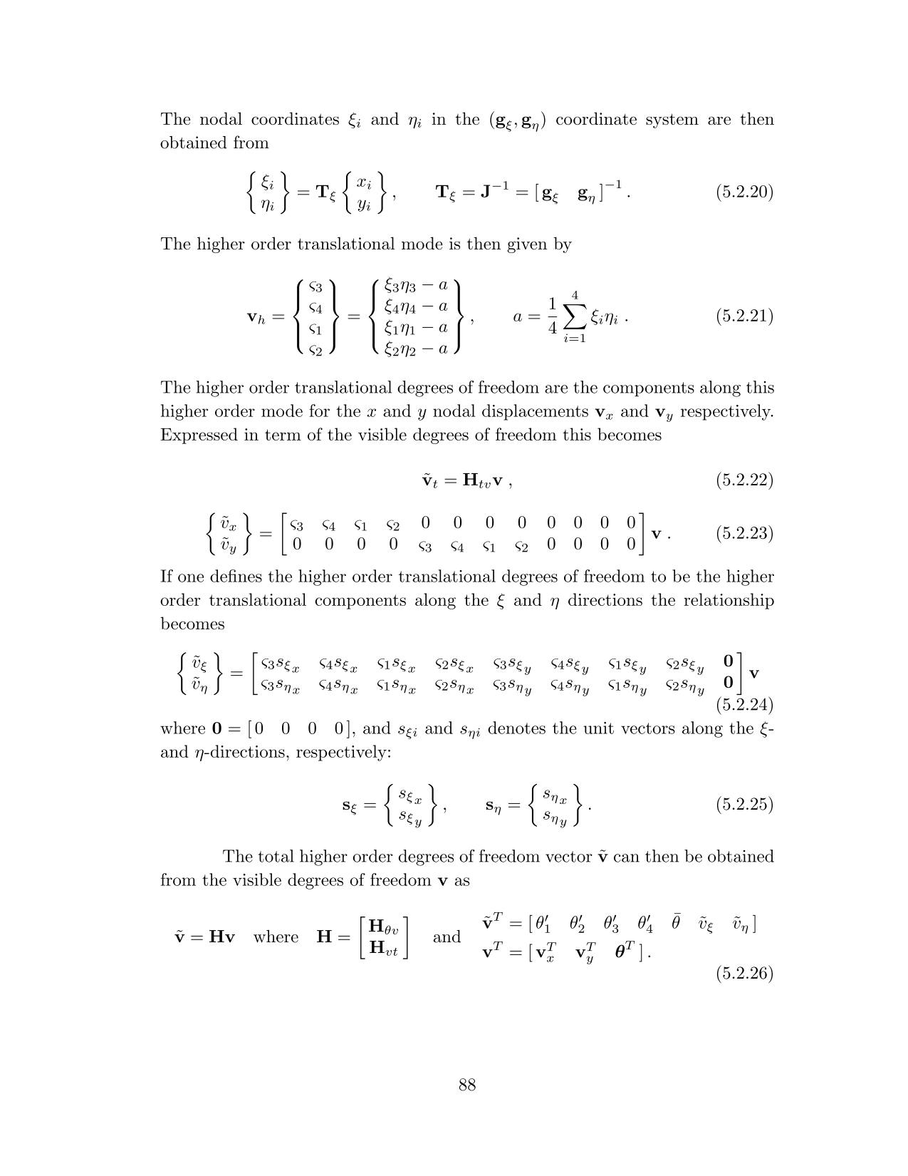

Considering p10 of Felippa’s supernatural quad paper:

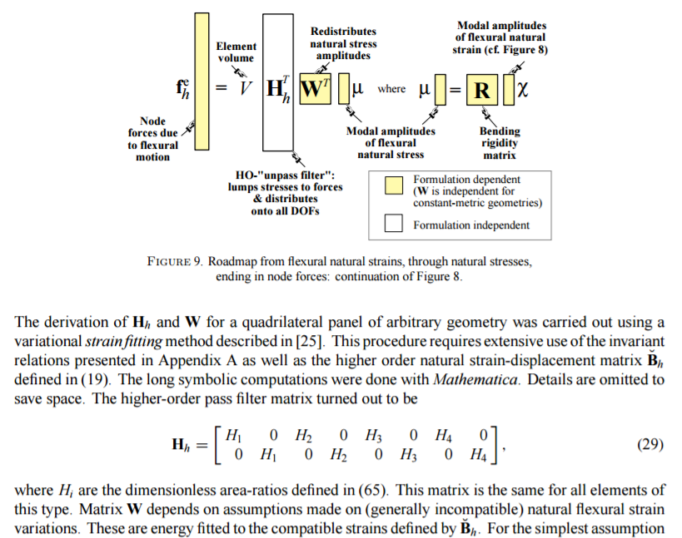

The values of v_h in Haugen eqn 5.2.21 turn out to be +/- 1. This corresponds to Felippa’s special case of the above for a **rectangular** element shape.

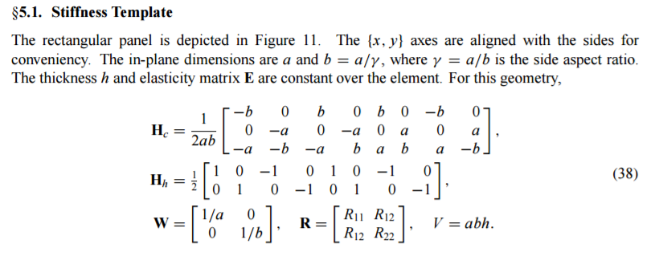

This might explain why we got good results with unskewed meshes, but skewed meshes departed from the rectangle filter matrix.

There is a factor of 2 different here though (ie. Haugen’s entries are |1|, while felippas are |0.5|).

The general computation for the coefficients H_i are:

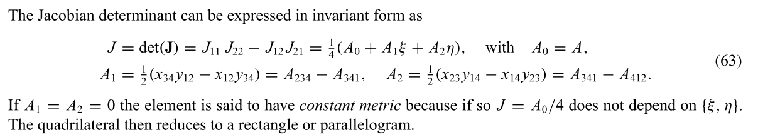

With

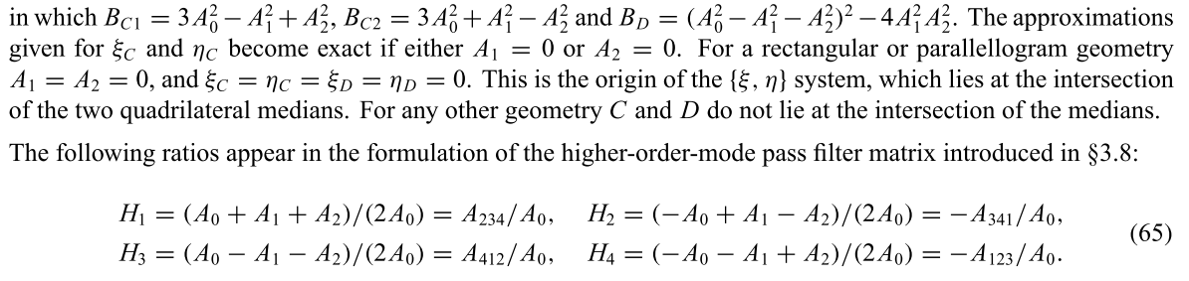

Replacing Haugen’s 5.2.23 coefficients with the ones above (which account for non-rectangular or non-parallelogram geometry), then transforming along the parametric directions according to 5.2.24, the performance of the element increases dramatically.

Regarding the factor of 2 between Haugen and Felippa – the element performs much better if Felippa’s H_tv matrix is used.

Also, the PhD thesis: “A geometric nonlinear solid-shell element based on ANDES, ANS and EAS concepts” by Mohammadreza Mostafa (under Felippa) also refers the use of these H values on p12:

